# ANNEX I - ODS

How to fill in the ODS online questionnaire

*Guide for undertakings submitting data in relation to*

*Article 27 of Regulation (EC) No 1005/2009 (the ODS Regulation)*

Once you open an Ozone Depleting Substances (ODS) reporting questionnaire, you will see the Welcome form (‘Introduction’). This form provides some basic information on who should report using the questionnaire. On the upper right corner you can see the information regarding your undertaking and the transaction (reporting) year.

In any form you can use the tabs in the grey area above the main part of the form to change between forms. In addition, the ‘Next’ button in the grey area underneath can help you navigate through the questionnaire in the correct order. The functioning of the ‘save’, ‘save & close’ and ‘cancel buttons follow the general principles described in page 9 of the BDR manual.

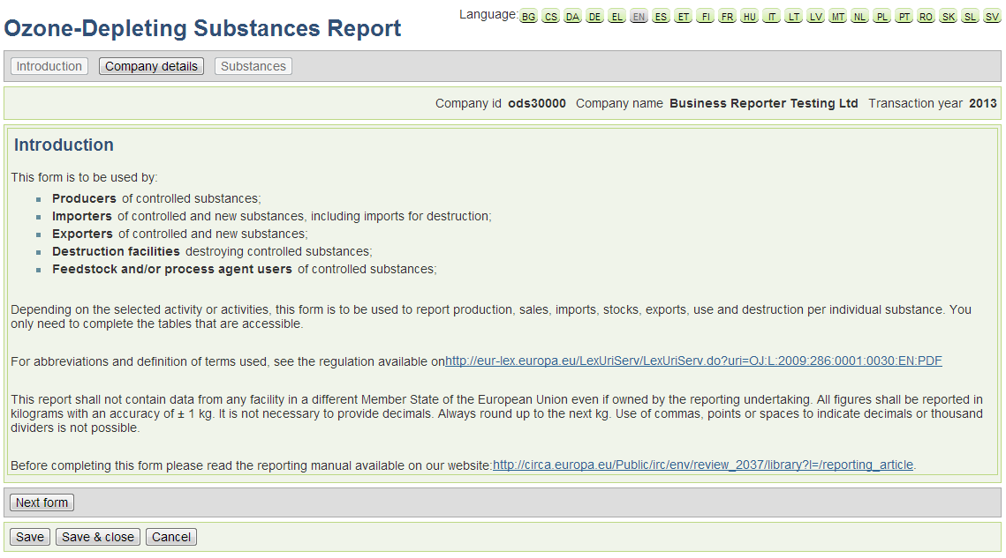

*‘Introduction’ form*

In order to start reporting data you will need to confirm your ‘Company Details’. In order to do so you can use the respective tab above or the ‘next form’ button. You will then see the following screen:

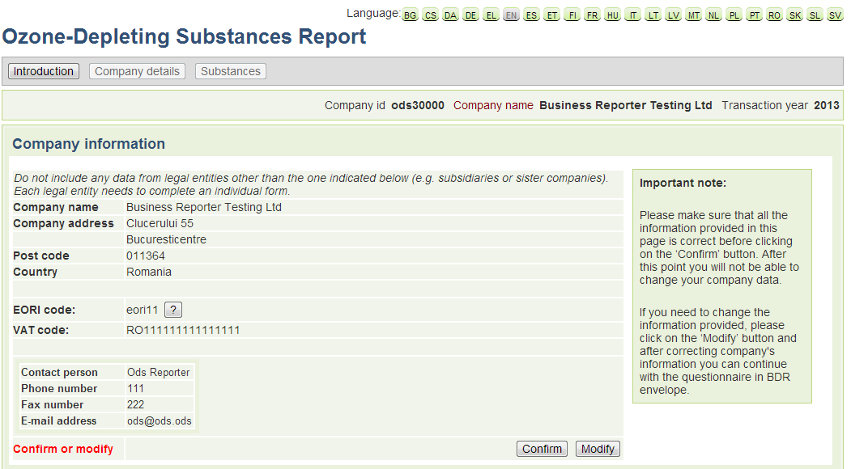

*Table 1: ‘Company Info’ - Step1*

You can either ‘Confirm’ the information of your company or ‘Modify’ any details if the shown information is incorrect. In case you need to modify your data, you will be redirected away from the online questionnaire and to the BDR (update organisation). A message box will be prompt to inform you that you are about to leave the current webpage. After you do the necessary changes in the ‘update organisation’ page, you can come back to the questionnaire and confirm your updated company data.

**Please make sure that your company information is correct in this step, as you will not be able to change that after you start completing the questionnaire!**

**You need to provide an EORI code if you are going to report activities related to imports/exports!**

Once you confirm, you will be able to indicate the reporting year (‘transaction year’) and the type of activities that have been performed by your company during that year. Select activities in these cases:

* Production; if you produced controlled or new substances in the transaction year and/or if you held stocks from production from previous year;
* Import: if you imported controlled or new substances in the transaction year and/or if you held stocks from previous year
* Export: if you exported controlled or new substances in the transaction year and/or held stocks from previous year
* Destruction: if you are a destruction facility and destroyed controlled substances in the transaction year or if you are a producer and destroyed controlled or new substances in your own facility in the transaction year;
* Feedstock use: if you used controlled substances as a feedstock in the transaction year or you reported on feedstock uses in previous years and still have stocks
* Process agent use: if you used controlled substances as process agent in the transaction year or you reported on process agent uses in previous years and still have stocks
* Not obliged to report: if you have nothing to report.

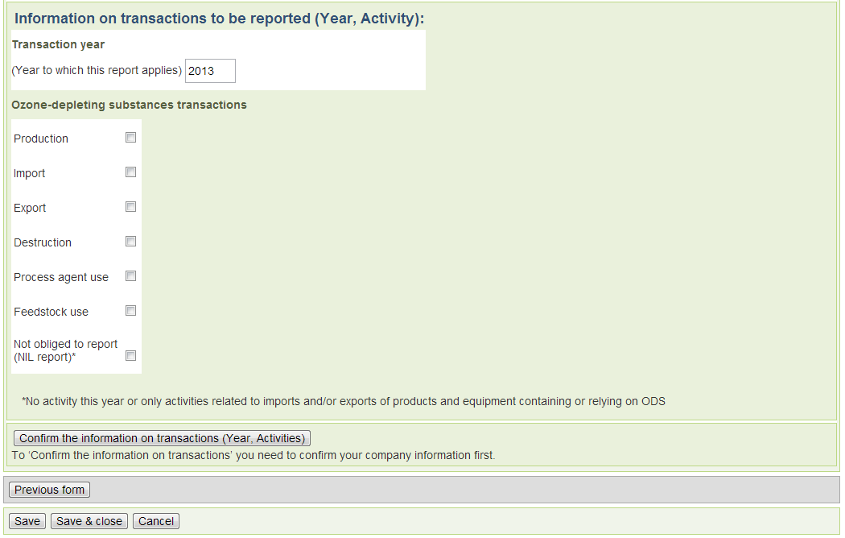

*Table 1: Information on transactions to be reported (Year, Activity) - Step2*

Please note that following this step you will not be able to view all the tables described in the next pages. This is because the tables shown on the online questionnaire depend on the type of activities you report at this stage. All the relevant tables you might need to use will be however available. For your assistance you can find hereby the list of tables corresponding to the different activities chosen:

Production: Table 3, Table 4, Table 5, Table 6, Table 8, Table 9, Table 10, Table 13

Import: Table 6, Table 7, Table 8, Table 10, Table 13

Export: Table 6, Table 8, Table 10, Table 11, Table 13

Destruction: Table 6, Table 8, Table 14

Process Agent use / Feedstock use: Table 6, Table 8, Table10, Table 12

Next you will need to click on the ‘Confirm the information on transactions (Year, Activites) ’ button to move to the next screen where you can introduce the substances that you will need to report:

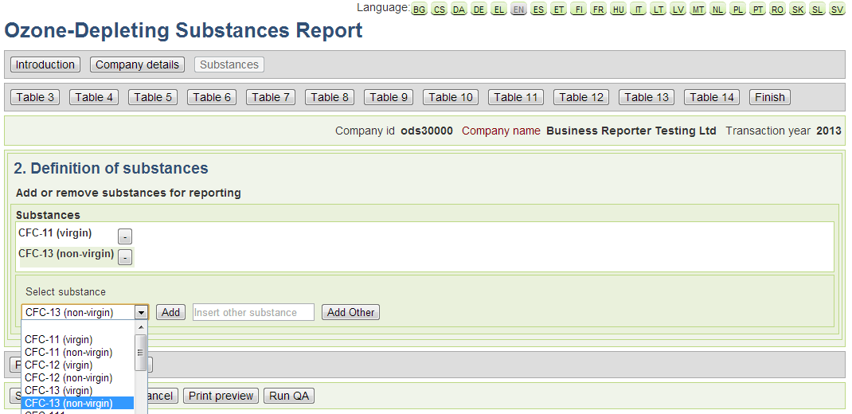

*Table 2: ’Definition of substances’*

In order to add a substance in your reporting, you need to select it first from the drop-down list and then add it using the ‘Add’ button at the right of the list. You can also add a substance that may be missing from the list by filling in the name in the open text field and using the ‘Add Other’ button. Make sure to be as precise as possible, including specifying if it is virgin or non-virgin. In case you selected and added a substance you do not need to report on, you can delete substances from the list by clicking on the ‘-‘ button.

In the next step (‘Table 3’) you must declare your undertaking’s production quantities per substance for the specific reporting year:

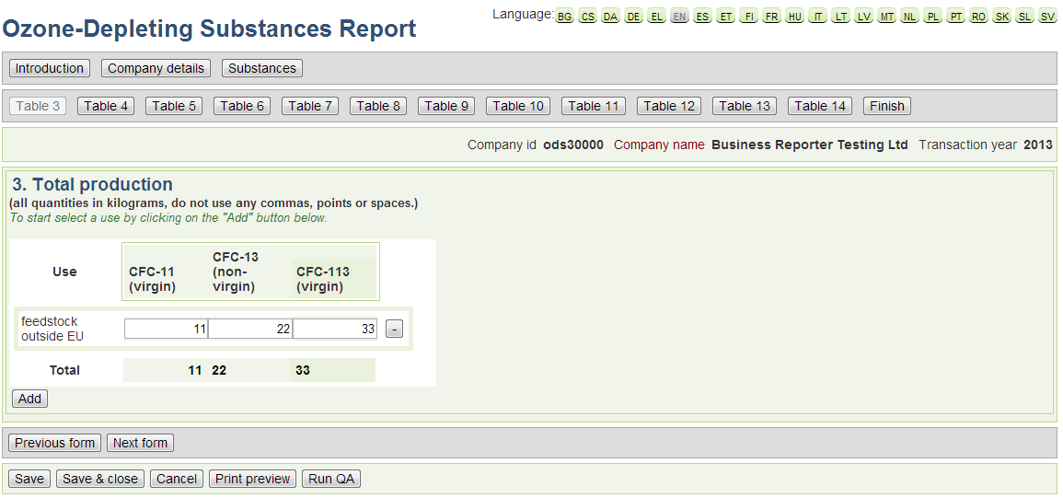

*Table 3: ‘Total production’*

To start reporting in this form you will first need press the ‘Add’ button and select the type of use from the drop-down menu which is relevant for you. In case you choose ‘Other’ from the drop-down list, you will be asked to provide more information on the intended use of the produced quantity. Once you select a use and fill in additional information (if required) you should click on the ‘Add’ button to add the use to the reporting table. It is possible to add more than one use to the reporting table.

By filing in the cells, you can report for each use the quantities produced for each substance indicated on the top of the column. Except for lab use and feedstock this includes your total production whether or not it is for use in the EU. For lab use and feedstock data needs to be segregated into production for use inside the EU and production for use outside the EU. Please note that in all forms the quantities must be in metric kilograms and that you should not use any commas, points or spaces!

Once you are satisfied with the reporting you can move to the next form (‘Table 4’). In this form you should indicate the quantities produced under industrial rationalization as outlined in Article 14 of the Regulation. Click the ‘Add’ button and fill in all the requested information. You need to indicate the undertaking which transferred the rights to you and you need to select the use for which the production took place. Press the ‘Add’ button to add the use to the reporting table and you can then report each substance’s quantities as applicable. For each transferring undertaking and use combination you need to add an individual row.

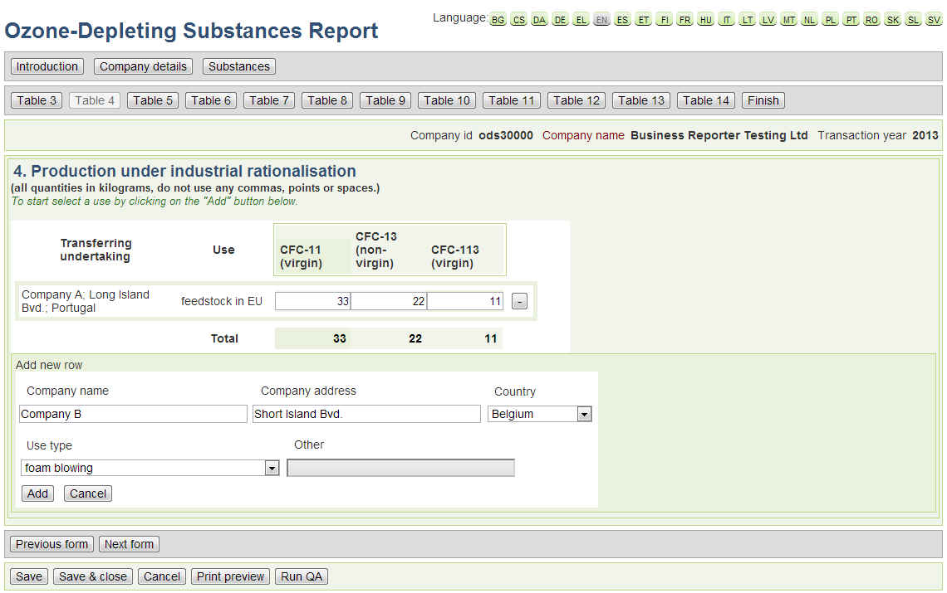

*Table 4: ‘Production under industrial rationalisation’*

In the next form (Table 5) you need to provide information on the recycled and reclaimed quantities. You only need to include recycled or reclaimed quantities of controlled or new substances in your undertaking. Do not include data from recycling or reclamation that took place in other undertakings. You can do this by filling in the empty cells for each declared substance respectively.

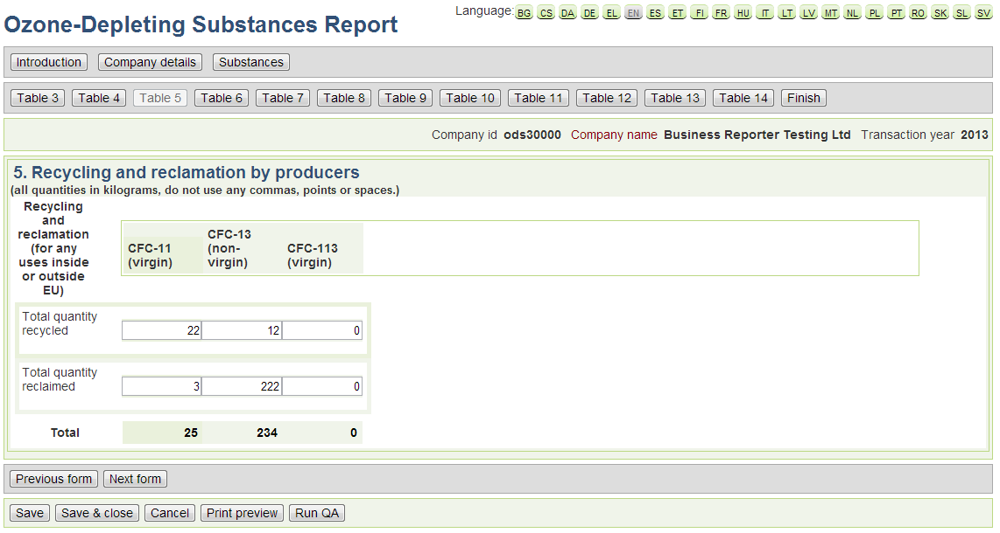

*Table 5: ‘Recycling and reclamation by producers’*

In Table 6 you need to provide the information on the quantities controlled substances and new substances (if applicable) received by any manner from other undertakings in the EU. This covers all incoming quantities such as purchases, returned goods and any other method of acquisition whether or not against payment. Also include any quantities that you received from sites of your own undertaking that are located in a different EU member state. Undertakings registered as re-packagers of HCFC under Article 11(5) of the Undertakings registered as re-packagers of HCFC under Article 11(5) of the Regulation need to report the origin of the goods they re-packaged. In case of returns from clients this must be the use for which you dispatched the substances.

In this form you should also identify the supplier (company name, address and country)and the type of intended use, by using the ‘Add’ button and fill the relevant info in the relevant areas (see also *Table 6*).

If you are a destruction facility and received waste from other undertakings, identification of the supplier is only mandatory when 1000 kg or more was obtained from a single undertaking. Data from undertakings supplying less than 1000 kg each may be aggregated. In this case use name “aggregated”, company address “aggregated” and your own country.

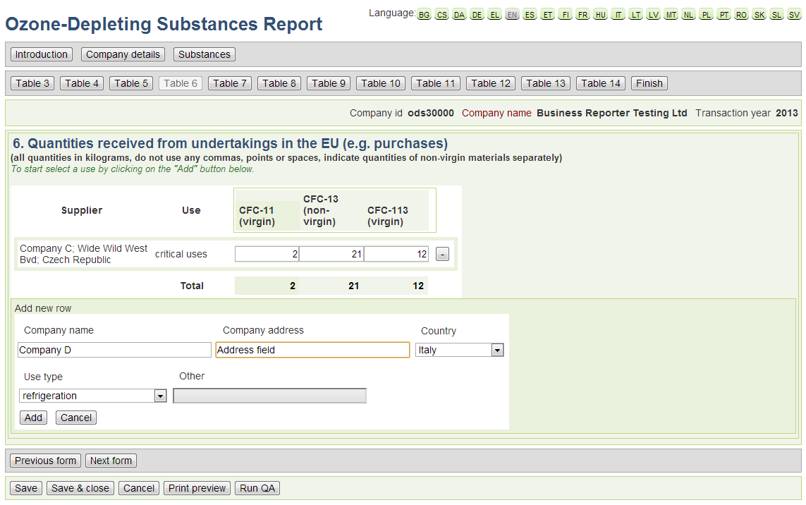

*Table 6: ‘Quantities received from undertakings in the EU (e.g. purchases)*

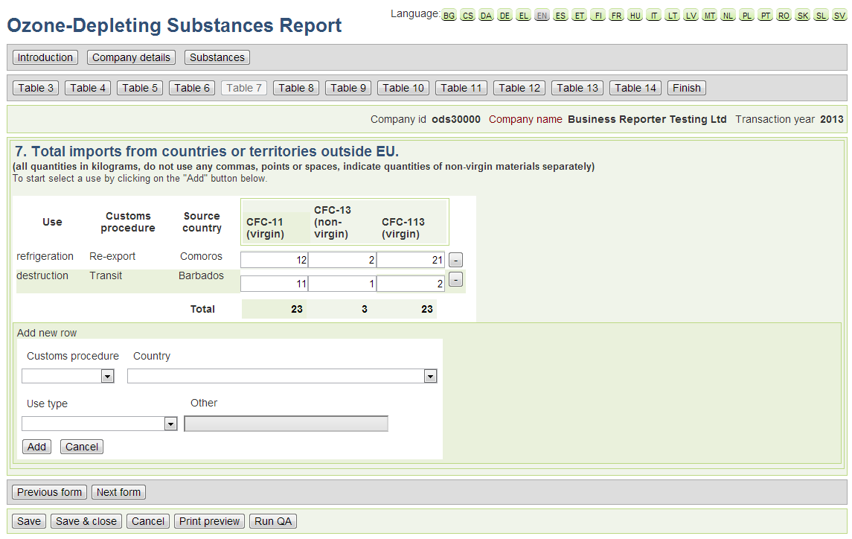

*Table 7: ‘Total imports from countries or territories outside EU (e.g. purchases)’*

In the next form (‘Table 7’), you should report quantities of controlled or new substances obtained by any manner from outside the EU. This covers all incoming quantities such as purchases, returned goods and any other method of acquisition whether or not against payment.

Note that some Member States have territories that are not part of the EU (e.g. Isle of Man, Greenland, French Polynesia and many others). Acquisitions from those territories also need to be reported here.

In this case the customs procedure should also be declared. The drop-down list allows for four options:

1. Free circulation: Release for free circulation including specific use (end use)
2. Re-export: Customs warehousing, free zone, temporary admission,
3. In-ward processing etc.
4. Re-import: Re-imports under the outward processing procedure etc.
5. Transit: Transit and trans-shipment

The non EU country should also be specified but no further information on the company producing the quantities is required.

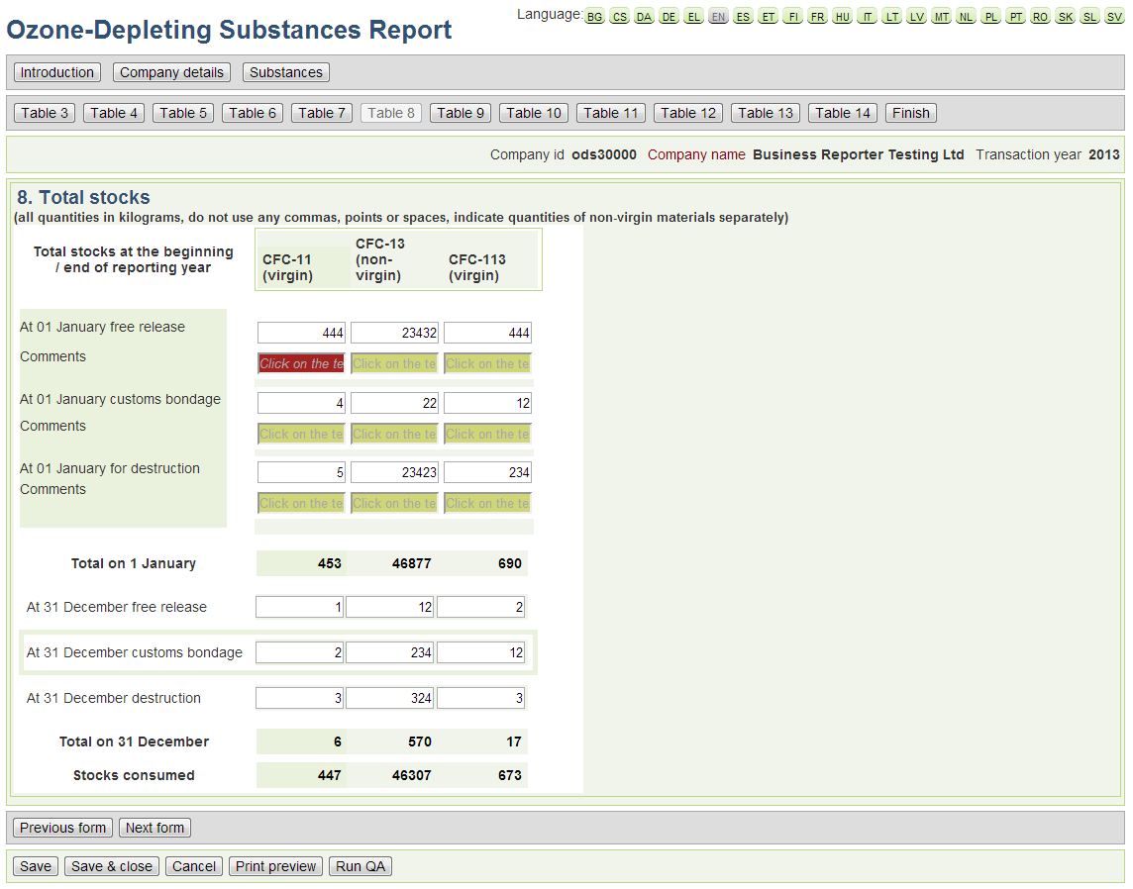

*Table 8: ‘Total stocks’*

Table 8 provide here the stocks that you held on 01 January and 31 December of the reporting year. The stocks need to be broken down by stocks that are bound by customs control measures (e.g. stocks in customs warehouses, free zones, transit etc.) and stocks that are not bound by such restrictions (i.e. those that can freely circulate in the EU). Furthermore, you need to indicate stocks of substances that will be destroyed separately.

Please note that the system will automatically detect any inconsistencies in the reporting with year X-1. In such cases a message box will automatically appear and you will be asked to provide a comment on the reasoning for this difference. You can add a comment in the field under each cell.

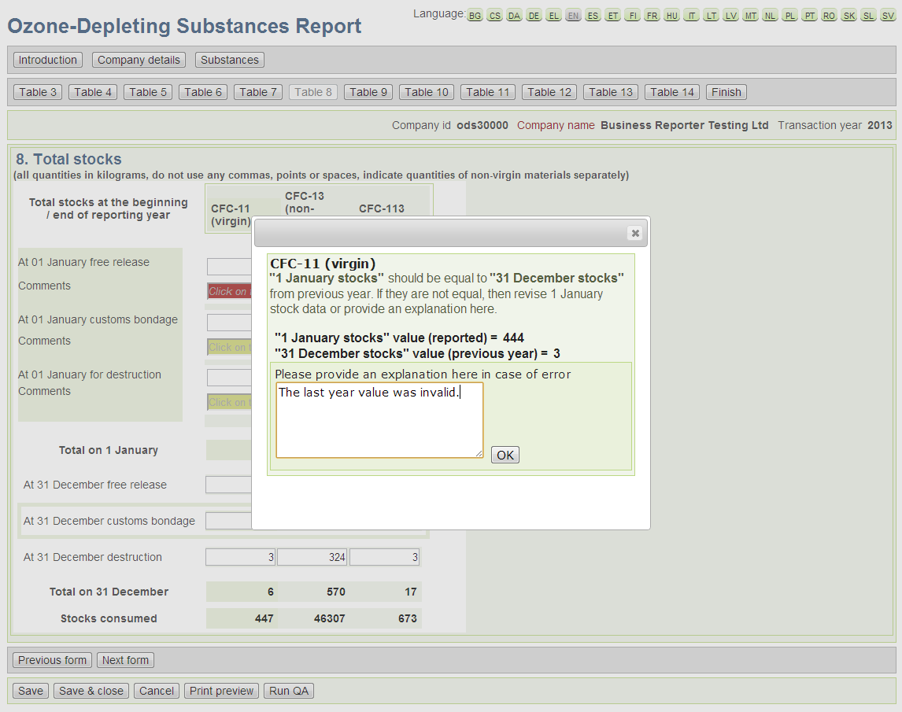

*Table 8: ‘Inconsistency in reporting of stocks’*

*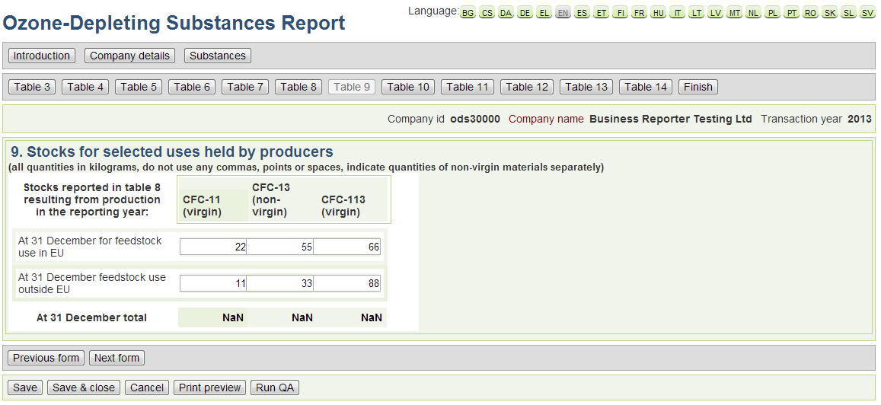Table 9: ‘Stocks for selected uses held by producers’*

The next form (Table 9) refers to the stocks held by producers for selected uses.

Provide in this table the portion of the stocks reported in table 8 that you held on 31 December of the reporting year and that resulted from a production during the reporting year. The quantities need to be broken down by stocks for feedstock uses in EU and feedstock uses outside the EU.

Do not include any stocks in this table that result from a production in earlier years.

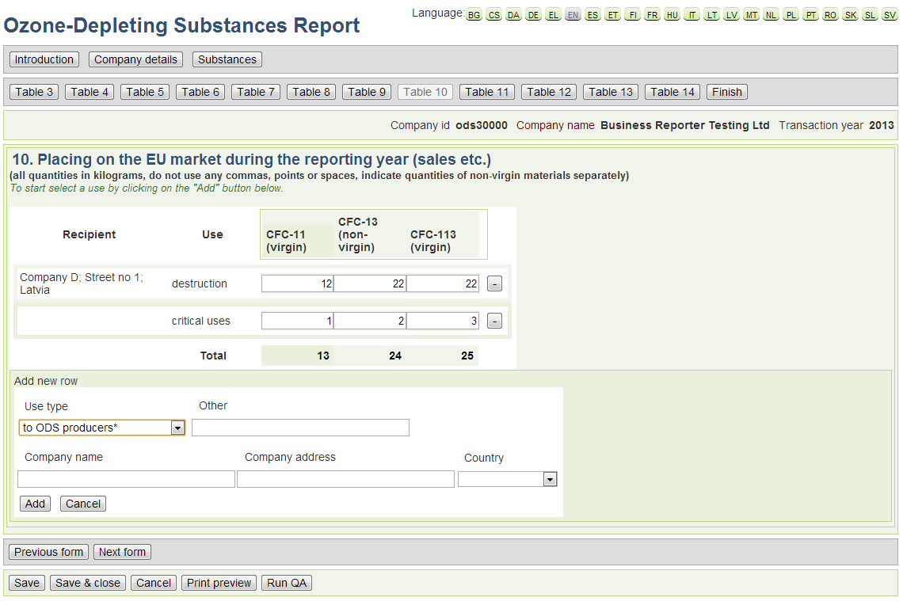

*Table 10: ‘Placing on the EU market during the reporting year (sales etc.)’*

In Table 10, you need to provide the quantities that your company placed in the EU market during the transaction year. For some uses (indicated with an asterisk) you need to provide the full name of the receiving undertaking and its full address. In case you should have supplied to more than one undertaking, add rows accordingly. This is the case for ‘destruction’, ‘feedstock’, ‘process agent’, ‘to EU-repackagers’,’ to ODS-reusers’ and ‘other uses’ you need to make sure that the quantities you declare here match the quantities reported in other parts of the questionnaire. If you selected destruction as use, please ensure that the company is the destruction facility and not an intermediary waste collector.

You can delete a row by using the minus (‘-‘) buttons at the end of each row.

In Table 11, you need to report exported quantities of controlled or new substances to a country or territory outside the EU. This covers all dispatched quantities such as sales, returned goods and any other method whether or not against payment.

Note that some Member States have territories that are not part of the EU (e.g. Isle of Man, Greenland, French Polynesia and many others). Substances exported to those territories also need to be reported here.

Again you need to give some basic details on the countries to which you have exported the specific quantities and on the type of uses.

.

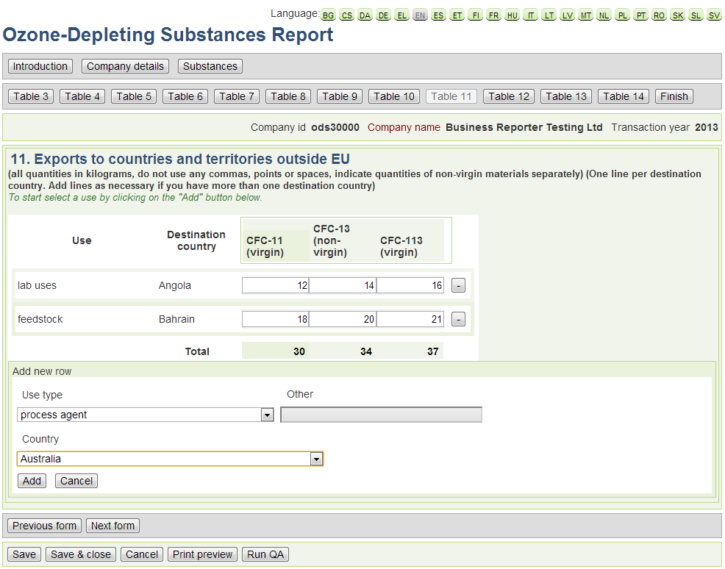

*Table 11: ‘Exports to countries and territories outside EU’*

The information on the feedstock and process agent use within your company should be provided in Table 12. Select from the list the entry that describes your feedstock (FDST) or process agent use (PAU). If your feedstock use process is not in the list, select FDST other and specify the process in the comments box. Note that you need to indicate the controlled substance and the specific chemical produced. For the produced chemical you need to provide a CAS Number. Generic descriptions (e.g. brominated salt, active pharmaceutical ingredient) will not be accepted.

For each process, report the make-up and the emissions. For make-up report the total quantity of the controlled substance (virgin or non-virgin) that has not been used in the process cycle before (i.e. those coming from stocks reported in field 205 under a) and that has been fed newly into the process cycle during the reporting year. For emissions report the quantities of controlled substances that were emitted into air, soil or water during the reporting year. Include all emissions whether from storage or from the process cycle. This covers all kinds of emissions including fugitive emissions or accidental releases. Emissions from industrial processes are unavoidable and it is therefore considered highly unlikely that there are no emissions from feedstock or process agent uses. Thus it will not be accepted if you report 0 or unrealistically low emissions.

You also need to provide the estimated quantities for next year.

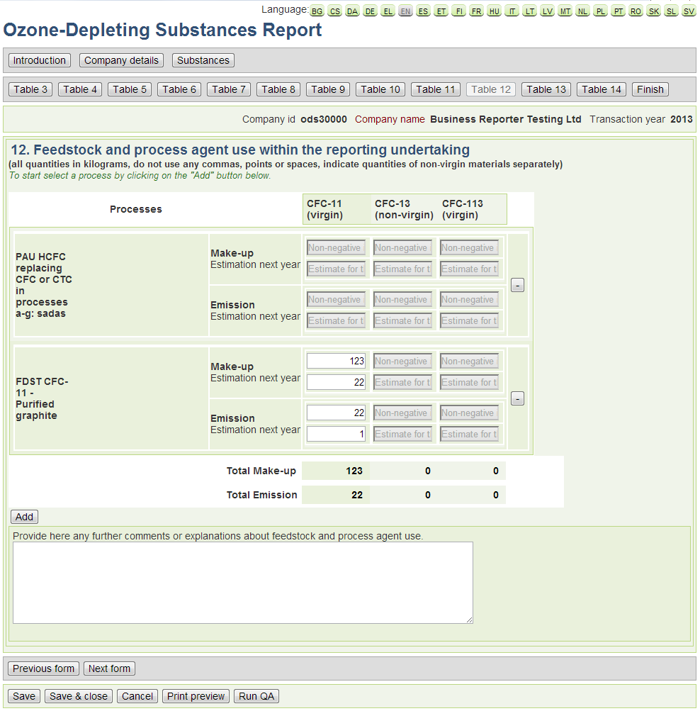

*Table 12:’ Feedstock and process agent use within the reporting undertaking’*

Please note that the quantities consumed by your company for other uses (not feedstock or process agent use) should be provided in *Table 13.* You need to complete table 13 if you used controlled or new substances in your undertaking, for other uses than feedstock or process agent use.

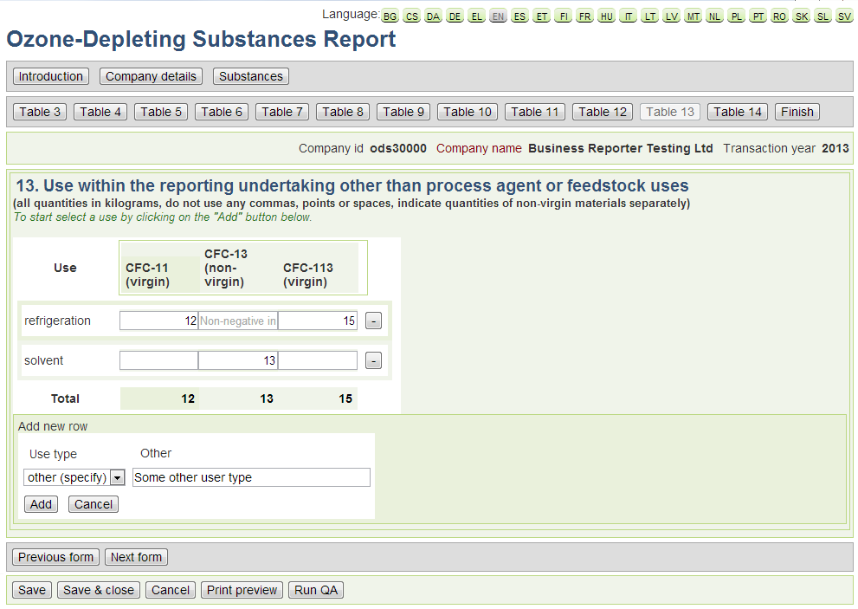

*Table 13:’* *Use within the reporting undertaking other than process agent or feedstock uses*

Table 14 refers to the amount of substances that have been destroyed by your undertaking during the reporting (transaction) year. This tables needs to be filled in if you are a producer and have a destruction facility that destroys controlled or new substances originating in your own undertaking or if you are a destruction facility destroying controlled substances originating from other undertakings.

Again you must use the ‘Add’ button to start reporting in this form. You will also need to specify the destruction technology(ies) that was used to destroy the waste.

*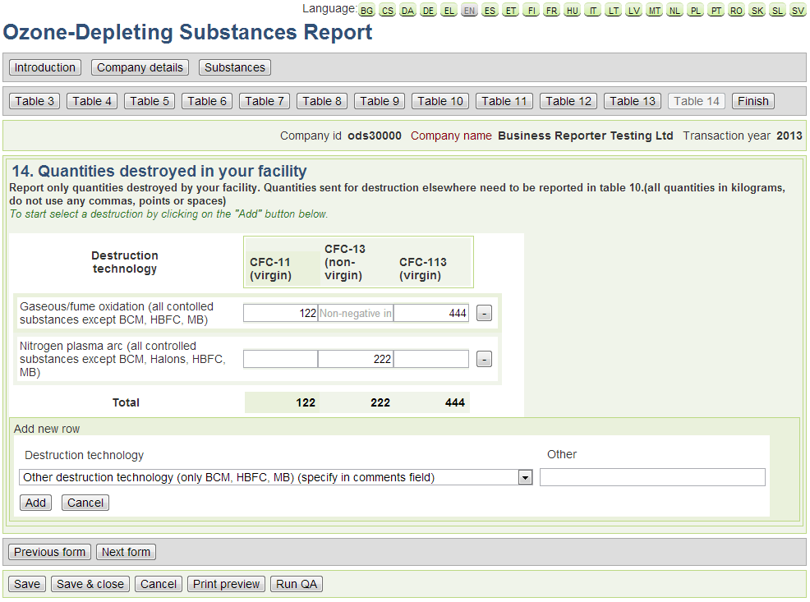Table 14: ‘Quantities destroyed in your facility’*

After *Table14* you finish the main reporting part of the questionnaire. In the finish form the comment box can be used to add any additional comments or clarifications you consider to be necessary or relevant.

To finalise the report, you need to certify that you are an authorized representative of the undertaking and that all the submitted information is true, accurate and complete (to your knowledge):

*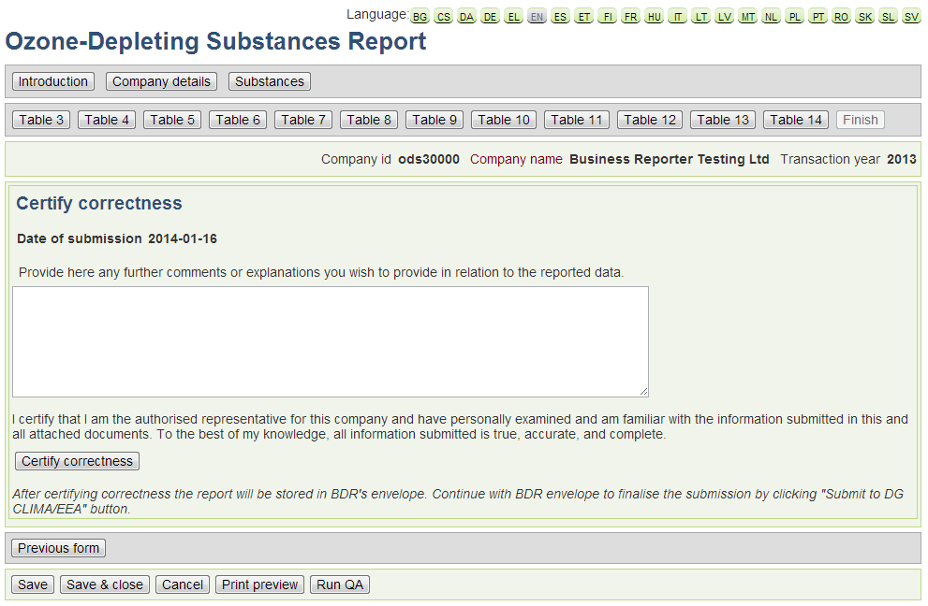‘Certify Correctness’ form*

After this step you will have concluded the questionnaire and you will see the following form, where you can click on the ‘Print Preview’ button to view the summarized information you are about to submit or on the ‘Run QA’ button in order to assess the quality of your report before submitting.

*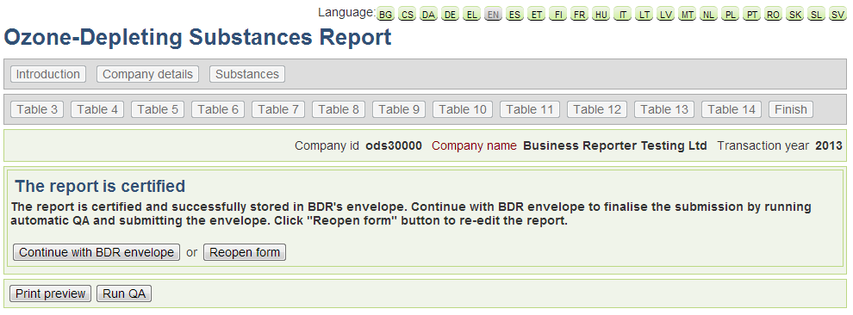Finalization of the Questionnaire*

If you are ready to submit then click on ‘Continue with the BDR envelope’ in order to continue with submitting the envelope to DG CLIMA/EEA. In this case, please refer to the main manual for more guidance on how to submit using the BDR system.

You may also choose to re-open the form in order to review/modify the data you have reported in the previous steps.